** YEAR 11 PHYSICS**

**MOVEMENT TEST 2**

**TASK 12**

**2019**

**Student name**: **SOLUTIONS**  **Marks:** / **43**

|  |  |
| --- | --- |
| Teacher:  Mr Boughton □  Mr Dopson G2 □  G3 □    Mrs Munshi □  Dr Pitts □ | Image result for physics cartoon images |

# **TIME**: 1 Hour

Data sheet supplied

**NOTE:**

1. Calculations must show clear working with answers stated to **three significant figures.**

2. Marks will be allocated for detailed and logical setting out.

3. Place your answer in the designated space under each question.

4.State **assumptions** while attempting open ended type questions.

5. Write in blue/black ink. It is advisable to use a pencil for graphing and drawing diagrams only.

1. In a game of soccer, a ball (mass = 350 g) travelling at 5.00 m s-1 struck the moving head of a player and rebounded at 6.00 m s-1  into the goal. The angle between the initial and final directions of the ball was 90o. Calculate the **change in momentum** of the ball. (3 marks)

- u

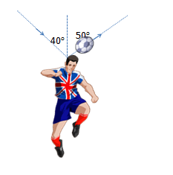

v

∆p = m ∆v = m(v-u) = m(v+(-u)) **(1)**

= 0.350 x √(62 + 52) = 0.350√61 **(1)**

= 0.350 x 7.810 = 2.73 kg m s-1

θ = tan-1 ( )

= 39.8o clockwise from the final velocity

**(0.5 + 0.5)**

2. An alpine skier, with a mass of 85.0 kg, is skiing at 16.15 m s-1 on firm snow.

Suddenly the skier travels across some fresh snow and experiences a retarding force of 520 N for 1.25 seconds against his motion.

After 1.25 s on fresh snow the skier again travels on firm snow. What is the final speed of the skier when the skier leaves the fresh snow? (4 marks)

F = m a **(0.5)**

a = $\frac{F}{m}$ = $\frac{-520}{85}$**(0.5)**

= - 6.118 m s-2 **(1)**

v = u + a t **(0.5)**

= 16.15 + (- 6.118 x 1.25) **(0.5)**

= 8.50 m s-1 **(1)**

3. Andrew drives a car with a mass of 1833 kg up a 15.0º slope at a constant velocity of 8.50 m s-1. The car experiences a constant friction of 350 N while travelling **up** the slope.



15.0Oo

Calculate the power output of the car when it is travelling at a constant velocity up the slope. (4 marks)

Net Fup the slope = mg sin θ + Ffriction  **(1)**

= (1833 x 9.8 x sin 15.0) + 350 **(0.5 + 0.5)**

= 4649.27 + 350 = 4999 N **(0.5)**

P = F vav **(0.5)**

=4999 x 8.50 = 4.25 x 104 W **(1)**

4. As we know, netball players can attain terrible shin and tendon injuries caused by the relatively large forces on their legs when they come to a sudden stop to pass or shoot the ball. Nellie the netball player has a mass of 58.2 kg and we can assume that all of her mass is pivoted on her forward leg as she comes to a stop. The total acceleration on her forward leg is 6g (58.8 m s-2). Determine

1. (i) the compression force along her leg. (2 marks)

F = ma **(0.5)**

= 58.2 x 58.8 **(0.5)**

= 3422

= 3.42 x 103 N along her leg **(0.5 + 0.5)**

(ii) the initial downward velocity of her foot just as it impacts the ground, given that her leg comes to a stop in 0.006 s. (2 marks)

F t = m (v – u) **(0.5)**

v = 0 **(0.5)**

3.42 x 103 x 0.006 = - 58.2 x u

u =

= - 0.353 m s-1 =0.353 m s-1 downwards **(0.5 + 0.5)**

b) Using key physics terminology, describe how a good netball or sports shoe minimises the impact force on an athlete’s legs and feet. (2 marks)

Sole of shoe causes change in momentum, **(0.5)**

I = Ft = m(v-u) = mv – mu **(0.5)**

**OR** deceleration, **(0.5)**

F = m a = m $\frac{(v-u)}{t}$**(0.5)**

over a longer period of time, **(0.5)**

therefore force experienced on athlete’s legs and feet is minimised. **(0.5)**

5. Mr. Dopson’s mighty blue Suzuki Sierra is travelling at a constant speed of 24.3 m s-1 up a long hill in Kalamunda, which is at an angle of 25.2o to the horizontal. The car has a total mass of 850 kg and the vehicle’s combined air and rolling resistance is approximately 7.50% of the car’s weight force.

a) Sketch and label the diagram of this situation below showing force vectors acting on the car whilst it is travelling up a slope at constant speed. (4 marks)

FR

Fapplied

Ff

Fw

**0.5** each for direction and name of each force

- 0.5 if force lengths Ff and Fapplied are not equal in length

- 0.5 if force lengths FR andFw are not equal in length

b) Determine the component of the car’s weight force acting parallel to the slope.

(2 marks)

F ll = mg sin θ

= 850 x 9.8 x sin 25.2 o **(1)**

= 3.55 x 103 N **(1)**

c) Determine the total force in the upward direction, parallel to the slope, acting on the car. (3 marks)

Fupward = F ll + Ff **(1)**

= (3.547 x 103 ) + (7.50% x 850 x 9.8) **(1)**

= (3.547 x 103) + (624.75)

= 4.17 x 103 N **(1)**

(d) Determine the work done by the car’s motor in order to move the vehicle 584 m along the slope at 24.3 m s-1. (3 marks)

W = Fupward . s (1)

= 4172 x 584 (1)

= 2.44 x 106 J (1)

6. The photograph shows the aftermath of a collision between a large truck and a much smaller car.

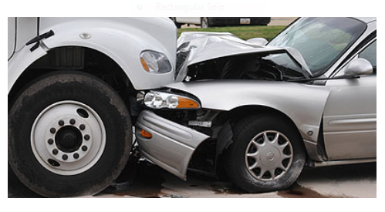

a) Which one of the statements below correctly states the comparative forces experienced by the two vehicles? Circle the correct answer. (1 mark)

1. The car experienced the largest force.
2. **Both vehicles experienced the same magnitude of force.**
3. The truck experienced the largest force.

b) Was the collision elastic? Explain your answer. (2 marks)

No. **(1)**

Kinetic energy was not conserved. **(0.5)**

It was converted into heat, sound

and used in deformation. **(0.5)**

7.

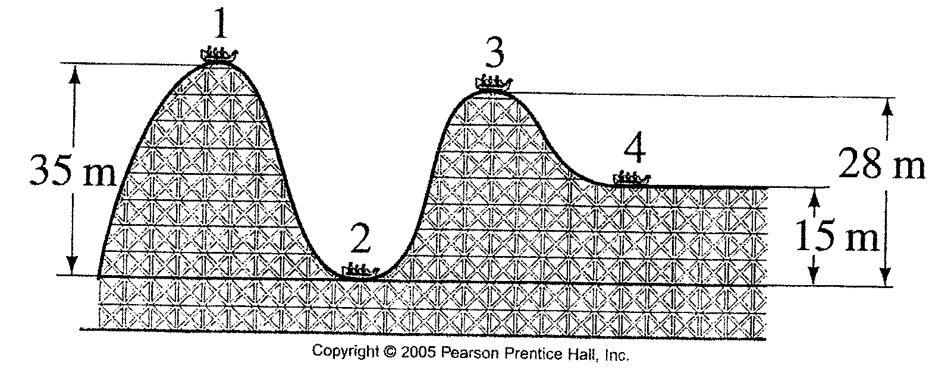

A carriage on the roller coaster with a total mass of 317 kg is travelling with an instantaneous horizontal velocity of 8.90 m s-1 at position 1. Ignore the effects of friction and calculate:

1. The total energy of the carriage at position 1. (2 marks)

ETOTAL at 1 = EP + EK = mgh + m v2 **(0.5)**

= 317 ((9.8 x 35) + 8.902)) **(0.5)**

= 1.21 x 105J **(1)**

1. The total energy of the carriage at position 2. (1 mark)

1.21 x 105J **(1)**

1. The speed of the roller coaster at position 2 . (2 marks)

ETOTAL at 2 = ETOTAL at 1

ETOTAL at 2 = EP + EK = mgh + m v2 **(0.5)**

= 0 + m v2 **(0.5)**

1.21285 x 105 = m v2 **(0.5)**

v = √ = 27.7 or 27.8 m s-1 **(0.5)**

1. The speed of the carriage at position 3. (3 marks)

ETOTAL at 3 = ETOTAL at 1 **(0.5)**

ETOTAL at 3 = EP + EK = mgh + m v2 **(0.5)**

1.21285 x 105 = 317 x 9.8 x 28+ x v2 **(1)**

v2 = 216

v = 14.7 m s-1 **(1)**

1. If the actual speed of the carriage at position 3 is 7.21 m s-1, what is the amount of energy used to overcome friction. (3 marks)

Actual ETOTAL at 3 = mgh + m v2 = 317 x 9.8 x 28+ x 7.212 **(1)**

= 95224 J **(1)**

Energy used to overcome friction = ETOTAL at 1- 95224 **(0.5)**

= 121286 – 95224 = 26062 J = 2.61 x 104 J **(0.5)**